**PRODUCT**

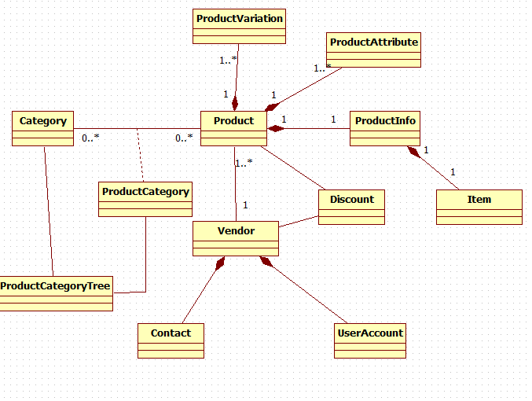

**MEMBER - CUSTOMER**

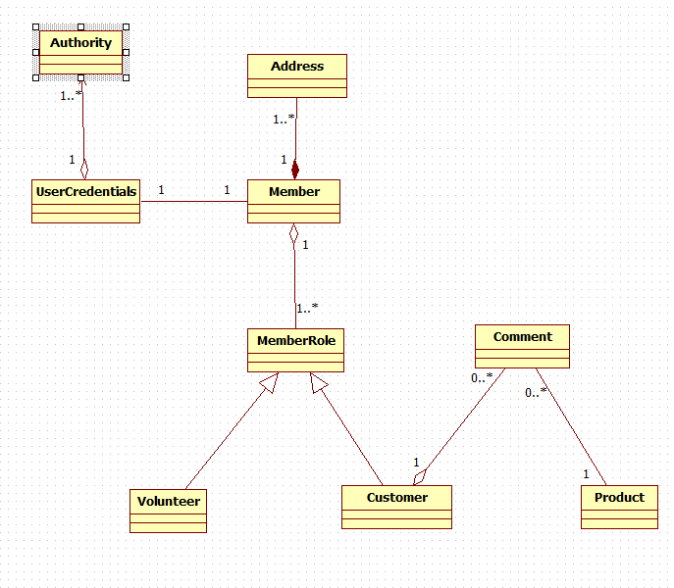

**CUSTOMER – ORDER - PRODUCT**

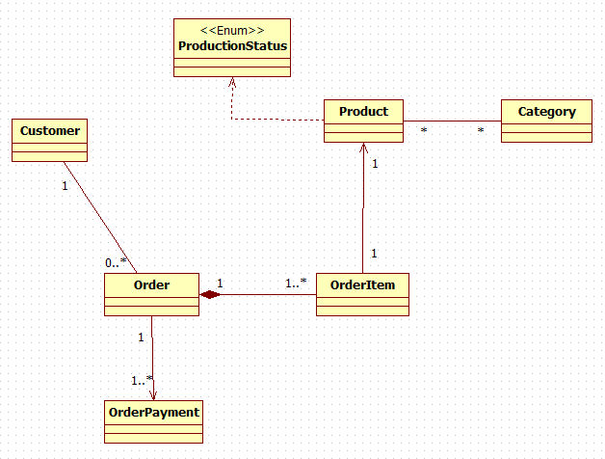

**Example Service Layer Use Cases [Rules & Hydration impact]:**

1. EOD Batch Load of products from new VENDOR.

Look up NEW product code based on vendor & product

**Disable [some] validation**

Save “draft” as multiple **saves** [Re: Cascade settings] -- product PLUS + Vendor + …

1. Admin

Hydrate “**Large**” ADMIN Product footprint

Relax validaton based on “state” [ New, inprocess, waiting approval, approved]

1. SOD Batch check for change in vendor discount based on product volume

Hydrate “**small**” product footprint PLUS Vendor PLUS discounted Objects

Check vendor net % of sales - adjust based on volume

Set new user price based on new price spread….

1. Customer

Get **CUSTOMER** footprint

Adjust price based on CUSTOMER status [Gold,Silver,Bronze, NONE] and based on price spread …

**External Standards/Conventions**

**Examples:**

Calculate Tax; Shipping Fee

Verify correct zip code for city/state;

Verify “valid” phone [e.g., certain exchanges not allowed];

Delivery date calculation

Financial Exchange rates